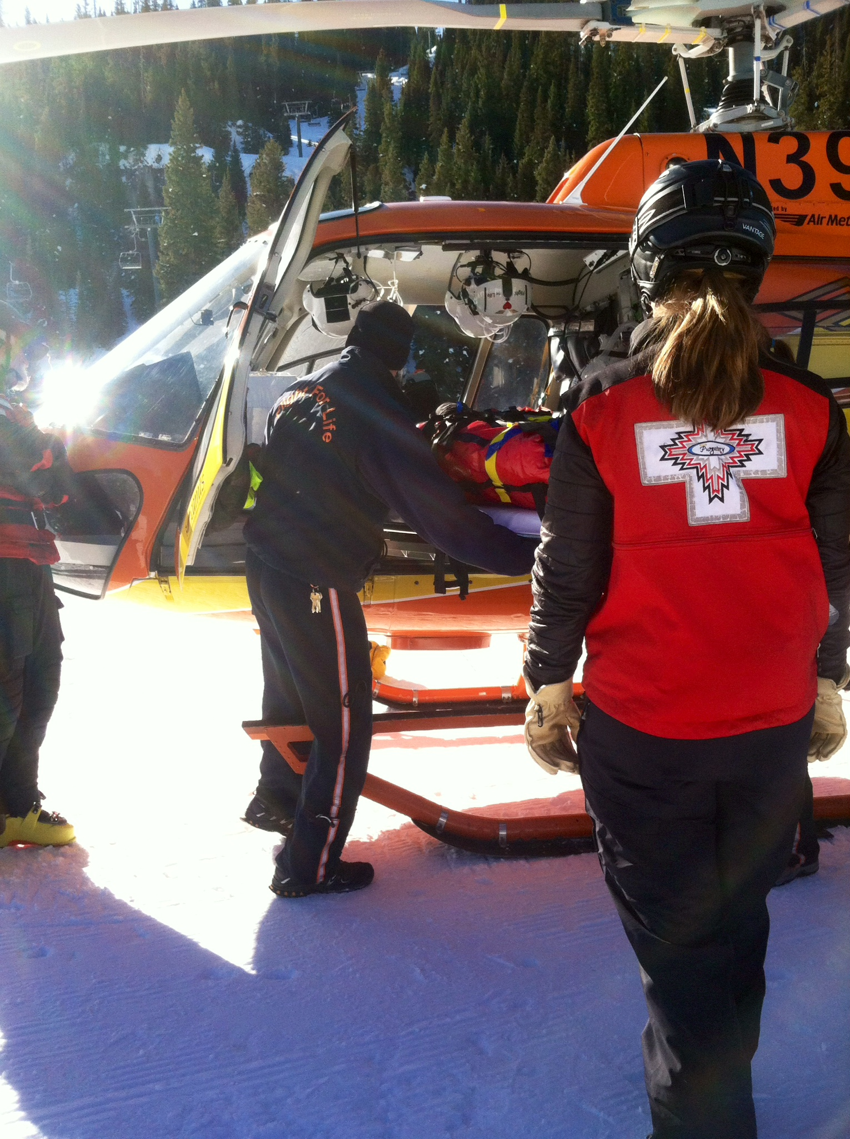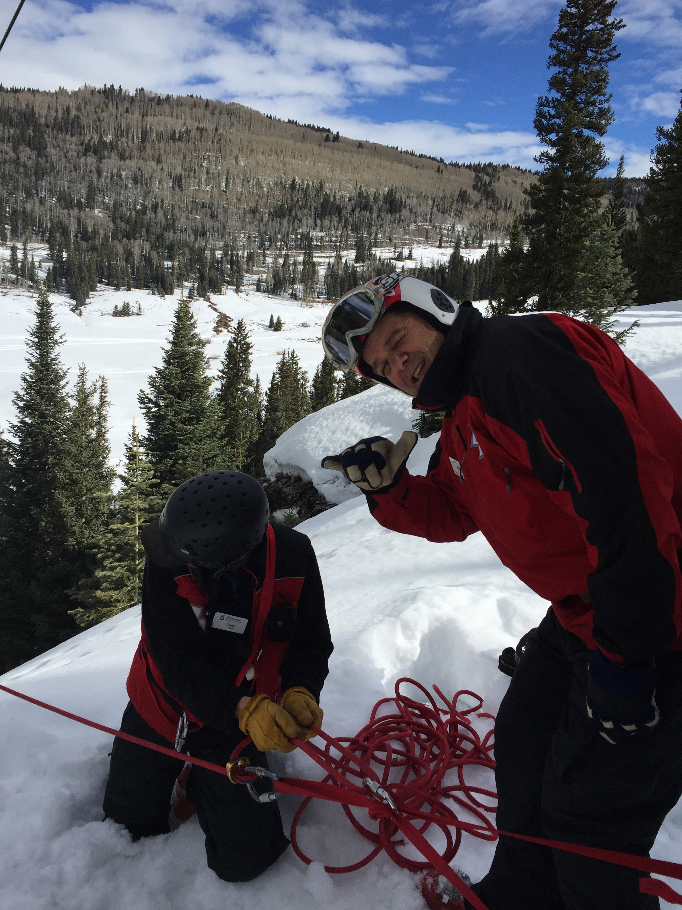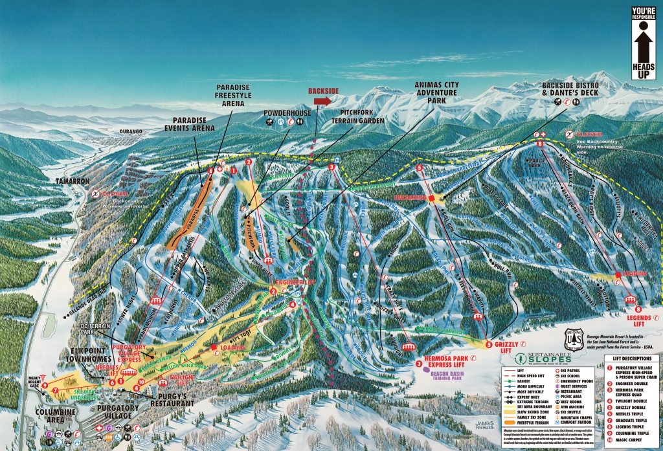

Our success is measured by your safe and good time at Durango Mountain Resort.  Here are a few tips to make your visit more enjoyable

-Ultra-violet rays are more severe at higher elevations.  Protect your skin from the effects of the sun and keep in mind that the snow reflects the sun's rays.  Wear sunscreen and eye protection such as sunglasses or goggles.

-Packed snow can be abrasive. We highly recommend wearing garments that cover your hands, arms and legs completely.

- Be prepared for quickly changing weather conditions.

- Dress in layers with your outer layer of clothing being of a water repellent fabric. Wear or carry a ski hat with you.

- Drink plenty of non-alcoholic liquids. Your body's tendency to dehydrate is greater at higher altitudes.

- On especially cold days, be aware of the potential for frostbite.

## Tips from Ski Patrol

**Ski Patrol**

**Safety Violations**

“Purgatory is committed to safety education, awareness and enforcement. Purgatory Mountain Patrol, Mountain Safety Staff (Yellow Jackets) and Mountain Management are enforcing skier safety on Purgatory Mountain every day.”

- Safety on the slopes is everyone’s responsibility. Ski safety not just for yourself, but for others.

-Always stay in control and be able to stop or avoid objects.

-People ahead of you have the right of way. It is your responsibility to avoid them.

-Do not stop where you obstruct the trail or are not visible from above.

-Whenever starting downhill or merging into a trail, yield to others.

-Always use devices to avoid runaway equipment.

-Observe all posted signs and warnings.

-Keep off closed trails and out of closed areas.

-Prior to using any lift, you must know how to load, ride, and unload safely.

## Know the Code!

## Staying safe on the mountain

***Eye on safety and fun!***

At Purgatory

* Frontside lifts run from 9am to 4pm. Backside lifts run from 9am to 3:30pm.
* There are 9 running lifts
* There are 5 terrain parks ranging in sizes and types of features.
* Trail difficulty ranges from easiest trail to extreme terrain.
* 20% of trails are beginner, 45% intermediate, and 35% Advance/Expert
* There are 88 trails to ski
* Summit elevation at the top of lift 8 is 10,822 ft. and the elevation at the base area is 8,793 ft.
* Purgatory does have backcountry access points

What should you do if you were to get injured?

If you do get injured while skiing or snowboarding at Purgatory you should remain calm and try to get the attention of someone else who can get help for you. You can also call Ski Patrol dispatch at **(970)-385-2178**.

It is important to know where you are so that if you do get injured and/or need help someone can find you. By using pinpoint locations on trails and trail intersections you will make it faster and easier for patrollers to find and assist you.

Once you have been found a ski patroller will assess you and your situation by asking many questions to learn more and by looking at the surrounding area. Depending on the situation a toboggan or snowmobile ride may be necessary to get you down the mountain safely.

In the Columbine area, below the village, there is a Ski Patrol room where you may first be taken after being assisted down by a patroller. You can reach the patrol room at (**970)-247-9000**. Because each injury is different and some may require special attention due to severity an injured skier/snowboarder may be referred to the Mercy Urgent Care adjacent to the patrol room. You can reach Mercy Urgent Care at Purgatory at **(970)-259-4553**. Both the patrol room and Mercy Urgent Care provide medical treatment and do see walk-in patients.

In case of a cardiac event it is important to know where AED are located.

* Top of lift 1 at the duty station
* Dante’s restaurant
* Powderhouse restaurant
* Purgatory Lodge at the front desk
* Patrol Room
* In the hallway inside by the ticket office and bathrooms.

According to the National Ski Area Association:

91% of children 9 years old or younger wear ski/snowboard helmets

81% of children between 10 and 14 wear ski/snowboard helmets

78% of adults over the age of 65 wear ski/snowboard helmets

53% of all 18 to 24 year olds interviewed wore helmets

At Purgatory Ski Area:

About 35% of skiers and snowboarders don’t wear a helmet and about 65% do wear helmets. This data was estimated based on the amount of injuries per year and skier/snowboarder observation. These percentages fluctuate during different times of the year depending on the tourism.

# Do I need a helmet?